**Ludlow Fire Lookout tree.**

**“Jack Watson Tree”.**

A couple of photos of the Ludlow fire lookout tree. Unable to unearth the construction date but I am told John (Jack) Watson had something to do with it. He was in Ludlow 1927-28 as OIC after completing his apprenticeship in the Ludlow forestry school located only 50 meters away. I would suggest the students of the first forestry school built in W.A. would have pegged this tree in their spare time. Ludlow is surrounded by tall forest and visibility is limited, by pegging this tree it became safe to climb and gave the locals the opportunity to scale the tree to see where smoke was coming from.

I removed the lower pegs in 1974 to stop the settlement kids from climbing it. The pegs are steel bar. The platform structure has collapsed, it never had a roof and only a rudimentary floor and hand rails. A couple of timber supports are still in place. The tree was used intermittently to get a fix on fires in or around the Tuart forest prior to Sea View tower being built.

The regrowth tuarts in the photo below were most likely planted adjacent to the lookout tree by the forestry students. (approx. 1 hectare). The planting lines can still be seen. This area had been cleared and use for agriculture by the former settler, land owner Mr Moriarty. This plot is the earliest known attempt to regenerate Tuart by hand with nursery raised planting stock. As far as can be determined this restoration plot has never been tended or thinned. Some of the mature trees died recently probably due to overcrowding and lack of silviculture. The remaining trees are about 100 Years old planted during the life of the school (1921 to 1927). The forest department had repurchased this property following the royal commission into the unmanaged forest industry in 1903. Its intention was to secure, manage and preserve the remaining tuart forest.

The pinaster pine is one of the original trial plantings nearby. It is now used as an anchor tree for the aerial rope network built by Forest Adventures. This tree would now be around 80 years old.

Forest Adventures is an amazing network of ropes, flying foxes, ladders and various aerial challenges. In the 1st 12 months of operation this facility attracted some 16,000 people. (I don’t have photos.) All of these people walk directly past “Watson tree” to access the car park recently built on the Ludlow settlement oval.

The fire lookout tree was spared from the axe or mattock during clearing for agriculture due to its size and condition. It is estimated this tree has survived some 500 years to reach its present size.

There is opportunity to feature this tree with signage to inform visitors to the area of the significance and history of the tree and surrounding area.

.

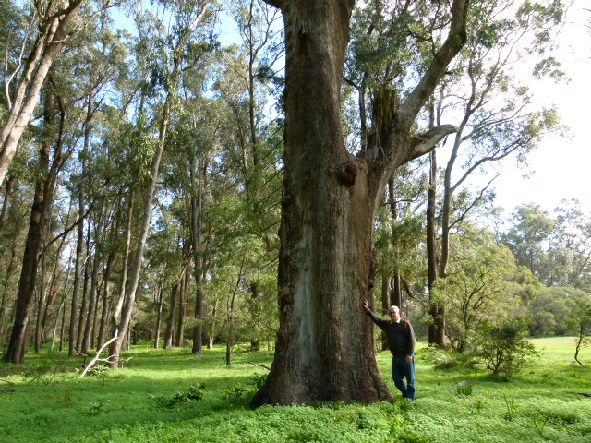 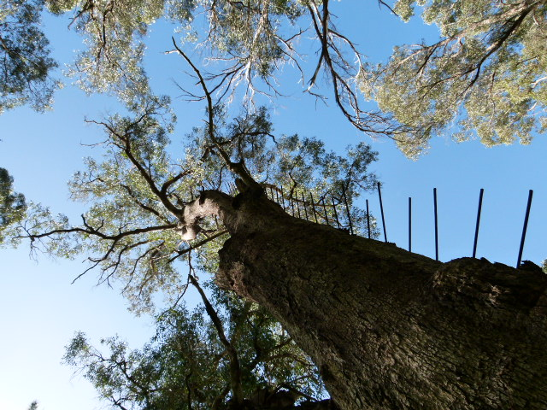

Ludlow fire lookout tree. 2nd view of lookout tree.

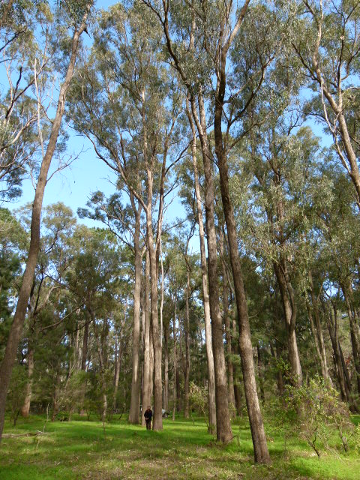 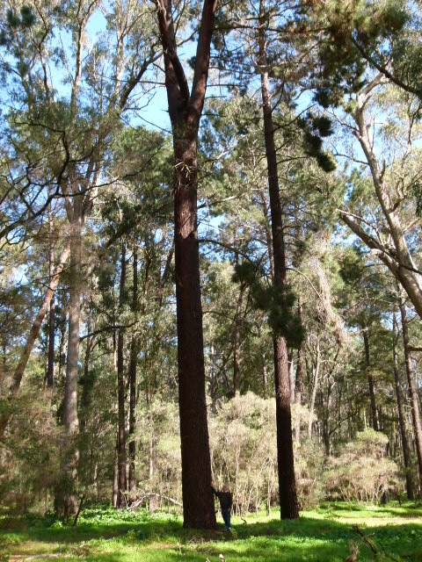

100 year old tuart regrowth hand planted. 80 year old pinaster pine Ludlow.

Ludlow around 1920.

Recently the LTFRG were loaned one of Jack Watson’s personal photo albums. Among the photos is one taken of the Gungin tower near Mundaring, built by Watson I believe using jarrah poles.

Recorded by Des Donnelly. 26.02.2020.